**BLINKIT DATA ANALYSIS – PYTHON PROJECT**

SELECT COUNT(*) FROM BlinkIT_Data

OUTPUT



UPDATE BlinkIT_Data

SET Item_Fat_Content =

CASE

WHEN Item_Fat_Content IN ('LF', 'low fat') THEN 'Low Fat'

WHEN Item_Fat_Content = 'reg' THEN 'Regular'

ELSE Item_Fat_Content

END

OUTPUT

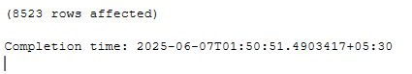

SELECT DISTINCT(Item_Fat_Content) FROM BlinkIT_Data

OUTPUT

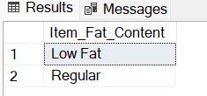

SELECT SUM(Sales) AS TOTAL_SALES FROM BlinkIT_Data

OUTPUT

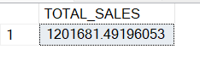

SELECT CAST(CAST(SUM(Sales)/ 1000000 AS DECIMAL(10,2)) AS VARCHAR)+'M' AS TOTAL_SALES_MILLIONS FROM BlinkIT_Data

OUTPUT

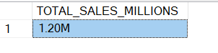

SELECT CAST(SUM(Sales)/ 1000000 AS DECIMAL(10,2)) AS TOTAL_SALES_MILLIONS FROM BlinkIT_Data

WHERE Item_Fat_Content = 'Low Fat'

OUTPUT

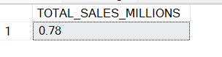

SELECT CAST(SUM(Sales)/ 1000000 AS DECIMAL(10,2)) AS TOTAL_SALES_MILLIONS FROM BlinkIT_Data

WHERE Outlet_Establishment_Year = 2022

OUTPUT

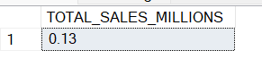

SELECT CAST(AVG(SALES) AS DECIMAL(10,1)) AS AVG_SALES FROM BlinkIT_Data

OUTPUT

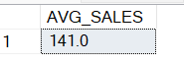

SELECT CAST(AVG(SALES) AS DECIMAL(10,1)) AS AVG_SALES FROM BlinkIT_Data

WHERE Outlet_Establishment_Year = 2022

OUTPUT

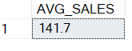

SELECT COUNT(*) AS NO_OF_ITEMS FROM BlinkIT_Data

WHERE Outlet_Establishment_Year = 2022

OUTPUT



SELECT CAST(AVG(Rating) AS DECIMAL(10,2)) AS AVG_RATING FROM BlinkIT_Data

OUTPUT



SELECT Item_Fat_Content, SUM(Sales) AS TOTAL_SALES From BlinkIT_Data GROUP BY Item_Fat_Content

OUTPUT

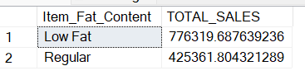

SELECT Item_Fat_Content, SUM(Sales) AS TOTAL_SALES From BlinkIT_Data GROUP BY Item_Fat_Content ORDER BY TOTAL_SALES DESC

OUTPUT

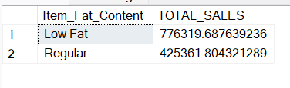

SELECT Item_Fat_Content, CAST(SUM(Sales) AS DECIMAL(10,2)) AS TOTAL_SALES

From BlinkIT_Data GROUP BY Item_Fat_Content ORDER BY TOTAL_SALES DESC

OUTPUT

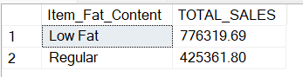

SELECT Item_Fat_Content,

CAST(SUM(Sales) AS DECIMAL(10,2)) AS TOTAL_SALES,

CAST(AVG(SALES) AS DECIMAL(10,1)) AS AVG_SALES,

COUNT(*) AS NO_OF_ITEMS,

CAST(AVG(Rating) AS DECIMAL(10,2)) AS AVG_RATING

From BlinkIT_Data GROUP BY Item_Fat_Content ORDER BY TOTAL_SALES DESC

OUTPUT

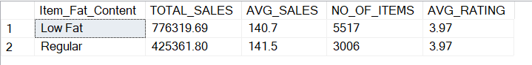

SELECT Item_Fat_Content,

CAST(SUM(Sales) AS DECIMAL(10,2)) AS TOTAL_SALES,

CAST(AVG(SALES) AS DECIMAL(10,1)) AS AVG_SALES,

COUNT(*) AS NO_OF_ITEMS,

CAST(AVG(Rating) AS DECIMAL(10,2)) AS AVG_RATING

From BlinkIT_Data

WHERE Outlet_Establishment_Year = 2020

GROUP BY Item_Fat_Content

ORDER BY TOTAL_SALES DESC

OUTPUT

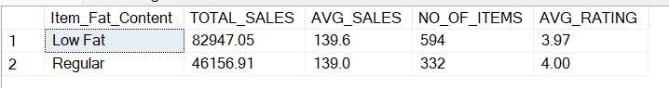

SELECT Item_Fat_Content,

CAST(CAST(SUM(Sales)/1000 AS DECIMAL(10,2)) AS varchar)+'K' AS TOTAL_SALES_THOUSANDS,

CAST(AVG(SALES) AS DECIMAL(10,1)) AS AVG_SALES,

COUNT(*) AS NO_OF_ITEMS,

CAST(AVG(Rating) AS DECIMAL(10,2)) AS AVG_RATING

From BlinkIT_Data

WHERE Outlet_Establishment_Year = 2020

GROUP BY Item_Fat_Content

ORDER BY TOTAL_SALES_THOUSANDS DESC

OUTPUT

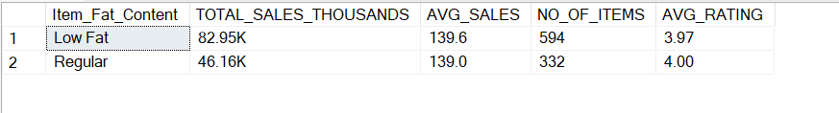

SELECT Item_Type,

CAST(CAST(SUM(Sales)/1000 AS DECIMAL(10,2)) AS varchar)+'K' AS TOTAL_SALES_THOUSANDS,

CAST(AVG(SALES) AS DECIMAL(10,1)) AS AVG_SALES,

COUNT(*) AS NO_OF_ITEMS,

CAST(AVG(Rating) AS DECIMAL(10,2)) AS AVG_RATING

From BlinkIT_Data

WHERE Outlet_Establishment_Year = 2020

GROUP BY Item_Type

ORDER BY TOTAL_SALES_THOUSANDS DESC

OUTPUT

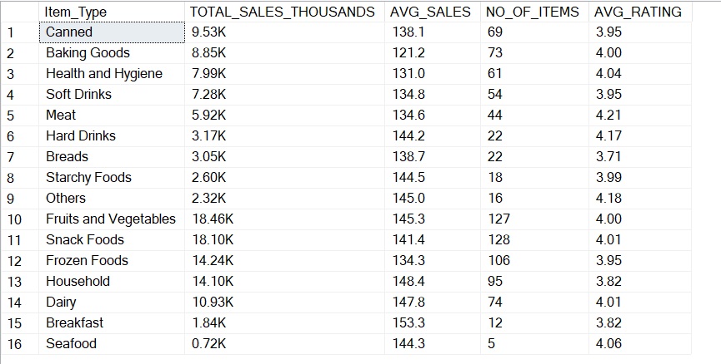

SELECT Item_Type,

CAST(SUM(Sales)/1000 AS DECIMAL(10,2)) AS TOTAL_SALES,

CAST(AVG(SALES) AS DECIMAL(10,1)) AS AVG_SALES,

COUNT(*) AS NO_OF_ITEMS,

CAST(AVG(Rating) AS DECIMAL(10,2)) AS AVG_RATING

From BlinkIT_Data

WHERE Outlet_Establishment_Year = 2020

GROUP BY Item_Type

ORDER BY TOTAL_SALES DESC

OUTPUT

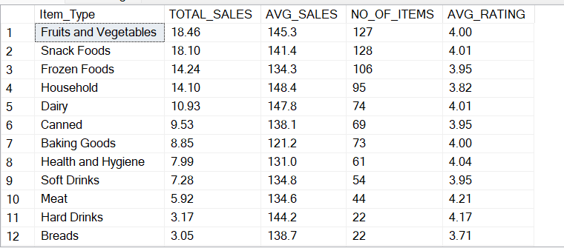

SELECT TOP 5 Item_Type,

CAST(SUM(Sales)/1000 AS DECIMAL(10,2)) AS TOTAL_SALES,

CAST(AVG(SALES) AS DECIMAL(10,1)) AS AVG_SALES,

COUNT(*) AS NO_OF_ITEMS,

CAST(AVG(Rating) AS DECIMAL(10,2)) AS AVG_RATING

From BlinkIT_Data

WHERE Outlet_Establishment_Year = 2020

GROUP BY Item_Type

ORDER BY TOTAL_SALES DESC

OUTPUT

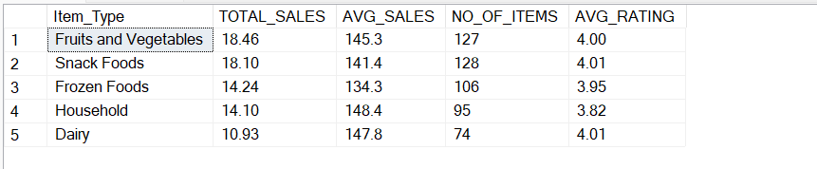

SELECT TOP 5 Item_Type,

CAST(SUM(Sales)/1000 AS DECIMAL(10,2)) AS TOTAL_SALES,

CAST(AVG(SALES) AS DECIMAL(10,1)) AS AVG_SALES,

COUNT(*) AS NO_OF_ITEMS,

CAST(AVG(Rating) AS DECIMAL(10,2)) AS AVG_RATING

From BlinkIT_Data

WHERE Outlet_Establishment_Year = 2020

GROUP BY Item_Type

ORDER BY TOTAL_SALES ASC

OUTPUT

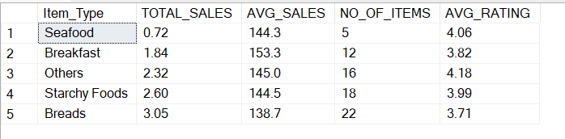

SELECT Outlet_Location_Type, Item_Fat_Content,

CAST(SUM(Sales) AS DECIMAL(10,2)) AS TOTAL_SALES,

CAST(AVG(SALES) AS DECIMAL(10,1)) AS AVG_SALES,

COUNT(*) AS NO_OF_ITEMS,

CAST(AVG(Rating) AS DECIMAL(10,2)) AS AVG_RATING

From BlinkIT_Data

GROUP BY Outlet_Location_Type, Item_Fat_Content

ORDER BY TOTAL_SALES ASC

OUTPUT

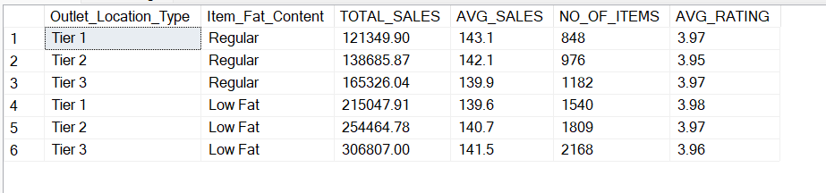

SELECT Outlet_Location_Type, Item_Fat_Content,

CAST(SUM(Sales) AS DECIMAL(10,2)) AS TOTAL_SALES

From BlinkIT_Data

GROUP BY Outlet_Location_Type, Item_Fat_Content

ORDER BY TOTAL_SALES ASC

OUTPUT

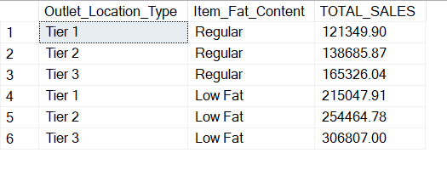

SELECT Outlet_Location_Type,

ISNULL([Low Fat], 0) AS Low_Fat,

ISNULL([Regular], 0) AS Regular

FROM(

SELECT Outlet_Location_Type, Item_Fat_Content,

CAST(SUM(Sales) AS DECIMAL(10,2)) AS TOTAL_SALES

FROM BlinkIT_Data

GROUP BY Outlet_Location_Type, Item_Fat_Content

) AS SourceTble

PIVOT(

SUM(TOTAL_SALES)

FOR Item_Fat_Content IN ([Low Fat],[Regular])

) AS PivotTable

ORDER BY Outlet_Location_Type;

OUTPUT

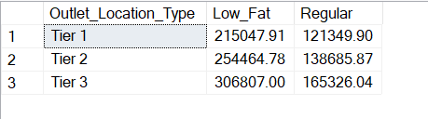

SELECT Outlet_Establishment_Year,

CAST(SUM(Sales) AS DECIMAL(10,2)) AS TOTAL_SALES

From BlinkIT_Data

GROUP BY Outlet_Establishment_Year

ORDER BY Outlet_Establishment_Year ASC

OUTPUT

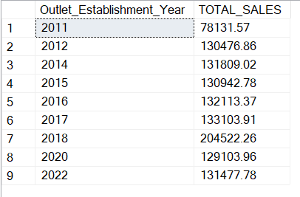

SELECT Outlet_Establishment_Year,

CAST(SUM(Sales) AS DECIMAL(10,2)) AS TOTAL_SALES,

CAST(AVG(SALES) AS DECIMAL(10,1)) AS AVG_SALES,

COUNT(*) AS NO_OF_ITEMS,

CAST(AVG(Rating) AS DECIMAL(10,2)) AS AVG_RATING

From BlinkIT_Data

GROUP BY Outlet_Establishment_Year

ORDER BY Outlet_Establishment_Year DESC

OUTPUT

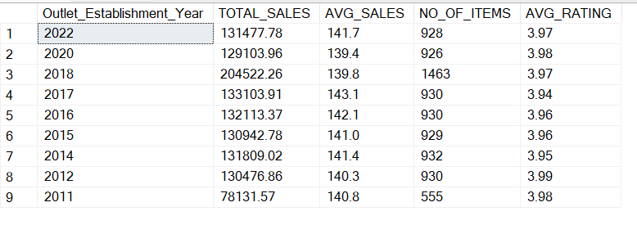

SELECT

Outlet_Size,

CAST(SUM(Sales) AS DECIMAL(10,2)) AS TOTAL_SALES,

CAST(SUM(Sales)*100.0 / SUM(SUM(Sales)) OVER() AS DECIMAL(10,2)) AS Sales_Percentage

From BlinkIT_Data

GROUP BY Outlet_Size

ORDER BY TOTAL_SALES DESC

OUTPUT

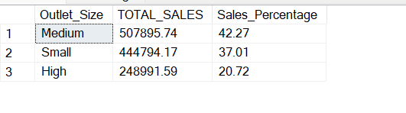

SELECT Outlet_Location_Type,

CAST(SUM(Sales) AS DECIMAL(10,2)) AS TOTAL_SALES,

CAST(AVG(SALES) AS DECIMAL(10,1)) AS AVG_SALES,

COUNT(*) AS NO_OF_ITEMS,

CAST(AVG(Rating) AS DECIMAL(10,2)) AS AVG_RATING

From BlinkIT_Data

GROUP BY Outlet_Location_Type

ORDER BY TOTAL_SALES DESC

OUTPUT

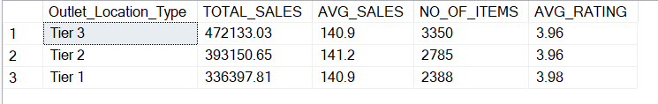

SELECT Outlet_Location_Type,

CAST(SUM(Sales) AS DECIMAL(10,2)) AS TOTAL_SALES,

CAST(SUM(Sales)*100.0 / SUM(SUM(Sales)) OVER() AS DECIMAL(10,2)) AS Sales_Percentage,

CAST(AVG(SALES) AS DECIMAL(10,1)) AS AVG_SALES,

COUNT(*) AS NO_OF_ITEMS,

CAST(AVG(Rating) AS DECIMAL(10,2)) AS AVG_RATING

From BlinkIT_Data

GROUP BY Outlet_Location_Type

ORDER BY TOTAL_SALES DESC

OUTPUT

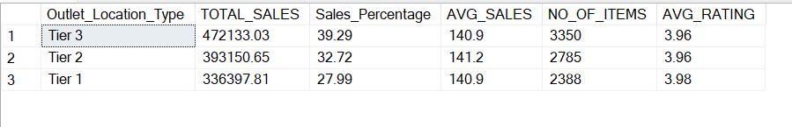

SELECT Outlet_Location_Type,

CAST(SUM(Sales) AS DECIMAL(10,2)) AS TOTAL_SALES,

CAST(SUM(Sales)*100.0 / SUM(SUM(Sales)) OVER() AS DECIMAL(10,2)) AS Sales_Percentage,

CAST(AVG(SALES) AS DECIMAL(10,1)) AS AVG_SALES,

COUNT(*) AS NO_OF_ITEMS,

CAST(AVG(Rating) AS DECIMAL(10,2)) AS AVG_RATING

From BlinkIT_Data

WHERE Outlet_Establishment_Year=2022

GROUP BY Outlet_Location_Type

ORDER BY TOTAL_SALES DESC

OUTPUT



SELECT Outlet_Type,

CAST(SUM(Sales) AS DECIMAL(10,2)) AS TOTAL_SALES,

CAST(SUM(Sales)*100.0 / SUM(SUM(Sales)) OVER() AS DECIMAL(10,2)) AS Sales_Percentage,

CAST(AVG(SALES) AS DECIMAL(10,1)) AS AVG_SALES,

COUNT(*) AS NO_OF_ITEMS,

CAST(AVG(Rating) AS DECIMAL(10,2)) AS AVG_RATING

From BlinkIT_Data

GROUP BY Outlet_Type

ORDER BY TOTAL_SALES DESC

OUTPUT

